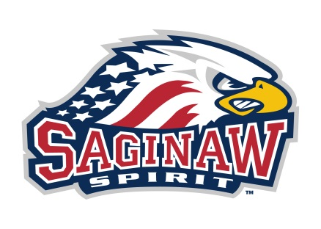

Saginaw Spirit Hockey Club –Invoice
Customer Name: Anthony Krenzel

Payment for:
Online order 4/30/21

- 1x Flint Firebirds - Official Game Puck
- 1x Guelph Storm - Official Game Puck
- 1x Kitchener Rangers - Official Game Puck
- 1x London Knights - Official Game Puck
- 1x Mississauga Steelheads - Official Game Puck
- 1x Sarnia Sting - Official Game Puck
- 1x Soo Greyhounds - Official Game Puck
- 1x Saginaw Spirit - Official Game Puck (Design #1)
- 1x Niagara Ice Dogs - Official Game Puck
- 1x Saginaw Spirit - Mini Goalie Stick
Subtotal (with discount 20%) $48.80 + tax $2.93
shipping $10.00

Total Amount Due: $ 61.73

If you have any questions about this invoice or to make a credit card payment, please call: (989) 497-7747. We accept: VISA, MASTERCARD, DISCOVER & AMERICAN EXPRESS.

